Networking Module 7&8

1. Try Test-Connection and nslookup commands for below websites
www.google.com
www.facebook.com
www.amazon.com
www.github.com
www.cisco.com

Sol:
Test-Connection:
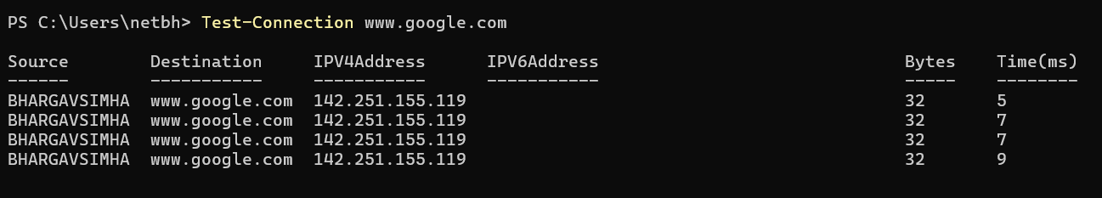
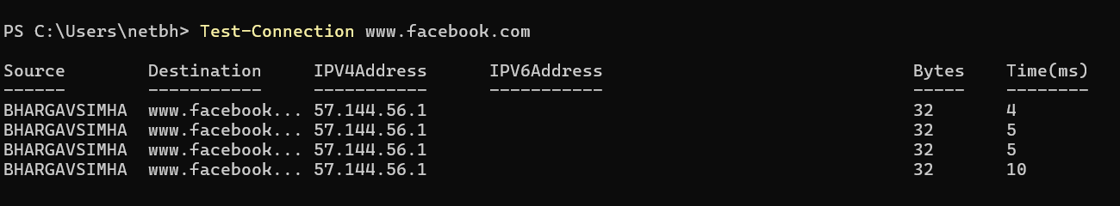
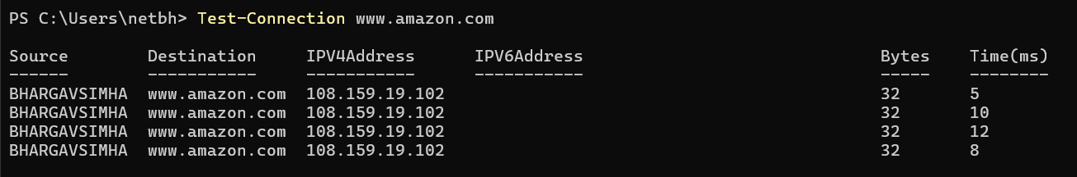
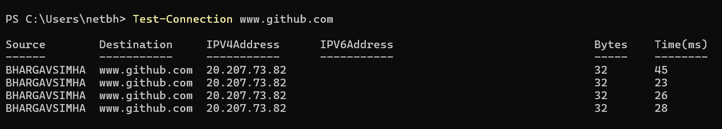
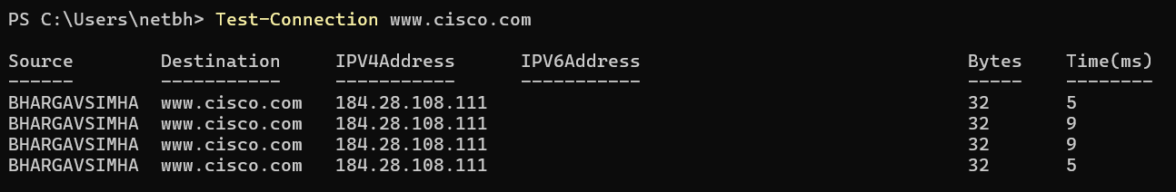

Test-Connection is PowerShell's equivalent of ping. It sends ICMP echo requests to check if a host is reachable and measures round-trip time.

Ns-lookup:

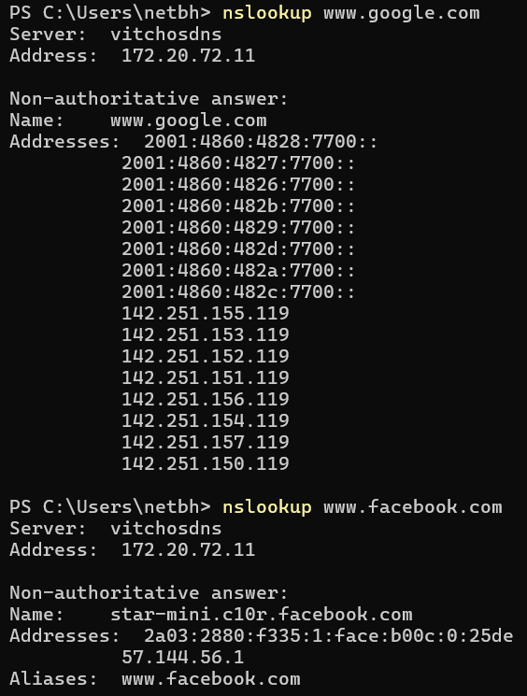
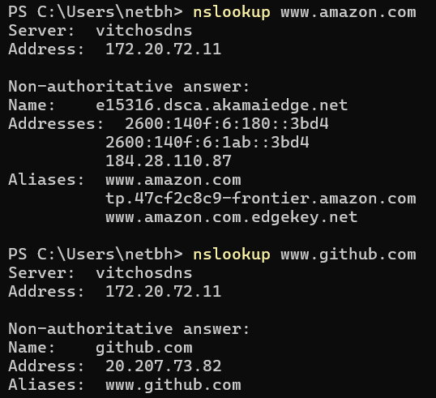
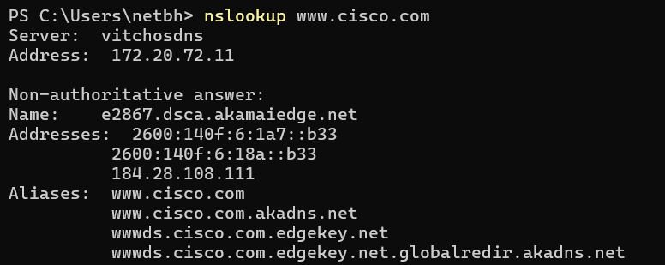

NSLookup (Name Server Lookup) queries the configured DNS server to resolve a hostname into its IP address. It reveals not just the final IP but also CNAME alias chains, whether the answer is authoritative or cached, and both IPv4/IPv6 addresses.

2. Use Wireshark to capture and analyze DNS, TCP, UDP traffic and packet header,
packet flow, options and flags.

Sol:
UDP AND DNS can be triggered in wireshark using nslookup to the website in terminal whereas for TCP we have to visit the website.
DNS CAPTURE:
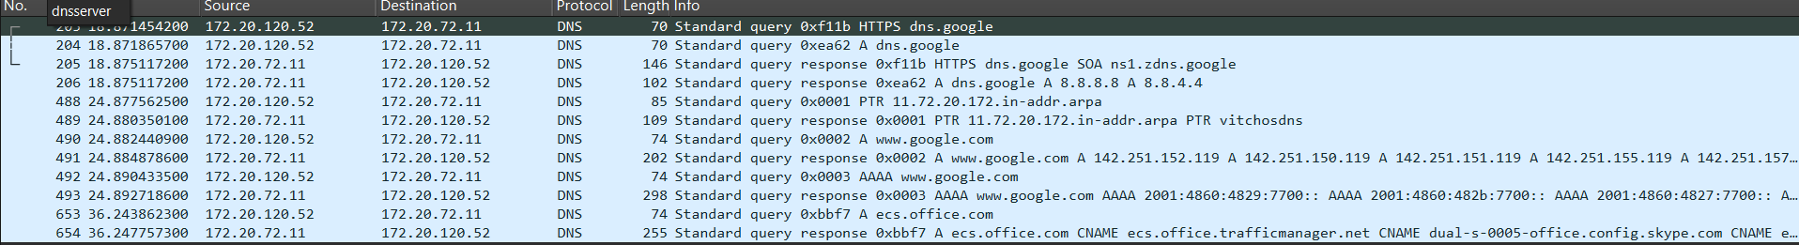

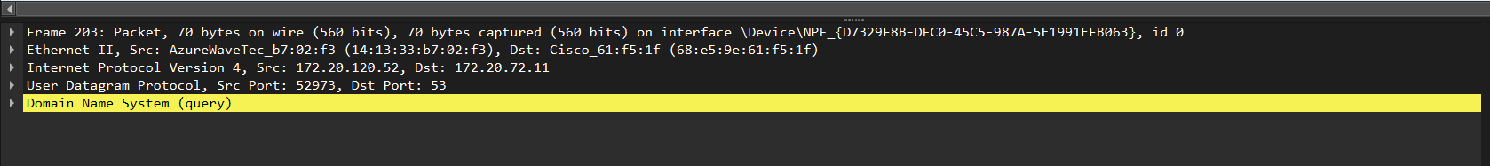
Frame Layer: Includes the packet number (e.g., No. 204), precise arrival time, and total length (e.g., 70 bytes). It identifies the encapsulation of protocols from Ethernet up to the DNS application.
Ethernet: Contains the Source and Destination MAC addresses to facilitate hardware-to-hardware communication between your laptop and the local gateway.
IP: Specifies IPv4 version and contains the Source IP (172.20.120.52) and Destination IP (172.20.72.11). It uses flags like 0x0 to set fragment offset and includes Time to Live (TTL) to prevent infinite loops.
UDP Layer: The laptop sends from an ephemeral source port to Destination Port 53, the standard DNS port. UDP length covers the header plus the DNS payload. No connection setup is needed; UDP fires the query directly without handshaking, making it faster.
DNS Layer: Uses a unique Transaction ID (e.g., 0xea62) to pair the "Standard query" for a domain like dns.google with its "Standard query response" containing the IP address 8.8.8.8.

TCP Capture:
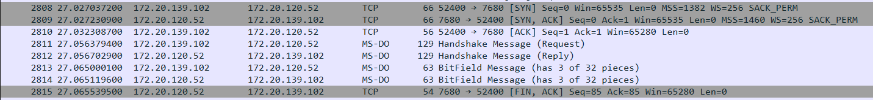
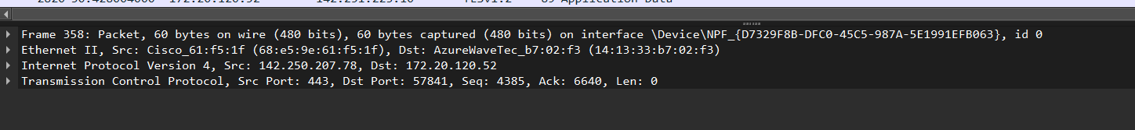

Frame Layer: Includes the packet number (e.g., No. 2808), arrival time, and a frame length of 66 bytes. It identifies the encapsulation of Ethernet, IPv4, and the TCP transport layer.
Ethernet: Contains the Source and Destination MAC addresses to facilitate the physical hardware-to-hardware data transfer between the two local hosts (172.20.139.102 and 172.20.120.52).
IP: Specifies IPv4 version and contains the Source IP (172.20.139.102) and Destination IP (172.20.120.52). It sets flags like 0x4000 (Don't Fragment) and includes Time to Live (TTL) to ensure the packet is routed correctly across the network.
TCP Layer: Unlike UDP, this is connection-oriented. It uses Source Port 52400 and Destination Port 7680. It manages the session via Flags:
- [SYN] (Packet 2808) to start the connection.
- [SYN, ACK] (Packet 2809) to acknowledge and synchronize back.
- [ACK] (Packet 2810) to establish the reliable "Three-Way Handshake." It uses Sequence and Acknowledgment numbers to ensure the "Handshake Message" and "BitField" data are tracked and delivered without error.
Application Layer (MS-DO): This is the actual data being sent after the TCP handshake is finished. It includes a "Handshake Message (Request)" and "BitField Message," showing the successful exchange of data over the established TCP connection.

UDP CAPTURE:
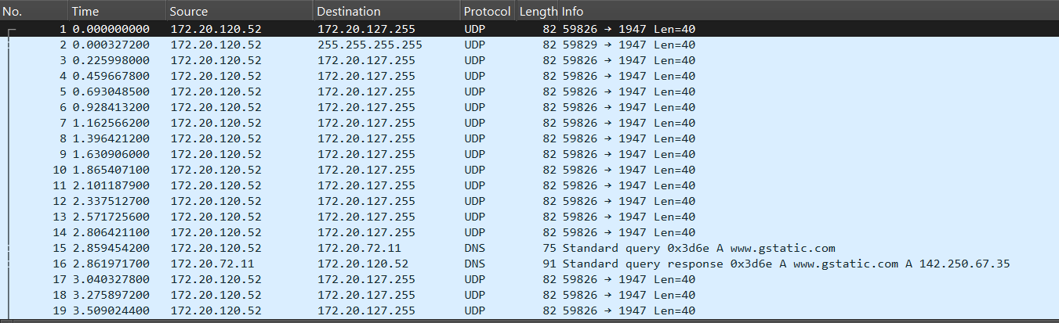
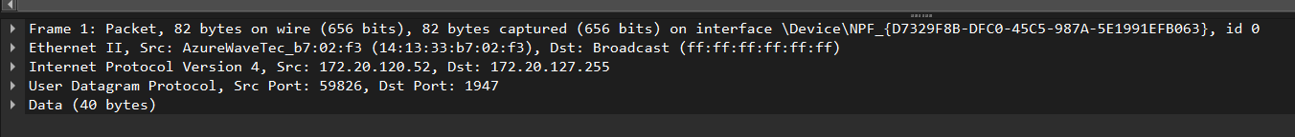
Frame Layer: Includes Frame 1, which contains 82 bytes of data. It shows a rapid arrival time, where the laptop is sending multiple packets (Packets 1–11) in quick succession to broadcast information across the local network.
Ethernet: Contains the Source MAC address (AzureWaveTec) and a Destination MAC address of ff:ff:ff:ff:ff:ff. This is a Broadcast address, meaning the physical frame is intended to be received by every device on the local network segment.
IP: Specifies IPv4 version and contains the Source IP 172.20.120.52. The Destination IP is 172.20.127.255, which is the directed broadcast address for this specific subnet. It uses a Time to Live (TTL) value to manage the packet's lifespan and identifies the transport protocol as UDP.
UDP Layer: The laptop sends from an ephemeral source port 59826 to Destination Port 1947. The UDP length covers the 8-byte header plus the 40 bytes of data payload. No connection setup is required; UDP simply "broadcasts" the data to the network without waiting for any acknowledgments, which is highly efficient for service discovery.
Data Layer: Contains 40 bytes of raw application data. In this capture, the data is being sent to port 1947 (often used by licensing services or hardware keys), acting as a "heartbeat" or discovery shout-out to see if other compatible devices or servers are present on the network.

3. Explore traceroute/tracert for different websites eg:google.com and analyse the
parameters in the output and explore different options for traceroute command.
Sol:
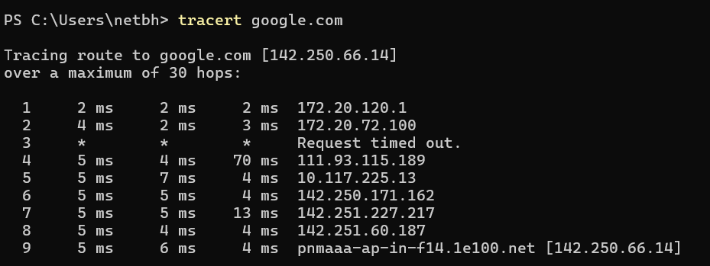

Path Breakdown:
- Hops 1–2: Local private network (172.20.x.x).
- Hops 4–5: Service Provider infrastructure (Public IPs).
- Hops 6–9: Google’s internal global network, ending at the final destination server.

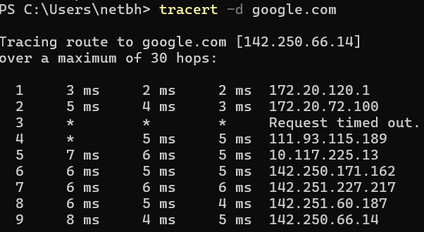

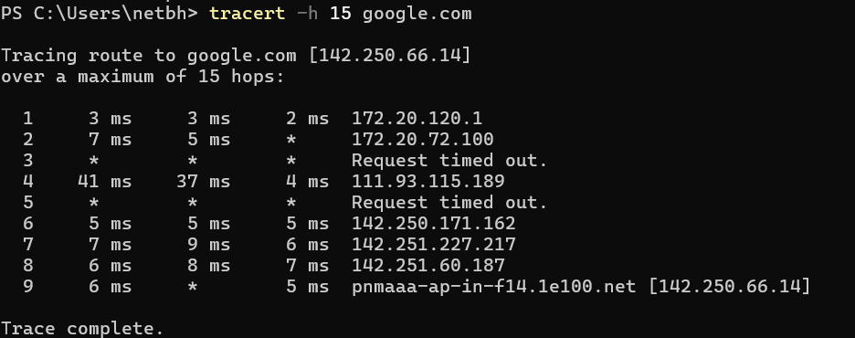

1. Fast Trace (-d)
- Command: tracert -d google.com
- Function: Tells the command not to resolve addresses to hostnames.
- Analysis: This is the most common option. By skipping the DNS lookup for every router along the path, the trace finishes much faster and only displays IP addresses.
2. Set Maximum Hops (-h)
- Command: tracert -h 15 google.com
- Function: Sets the maximum number of hops to search for the target.
- Analysis: By default, tracert tries up to 30 hops. If you know a server is close, or you want to stop the trace early to save time, you can lower this value (e.g., to 15).

4. Use Cisco packet tracer for the below
5. Set up trunk ports between switches and try ping between different VLANs.

Sol:
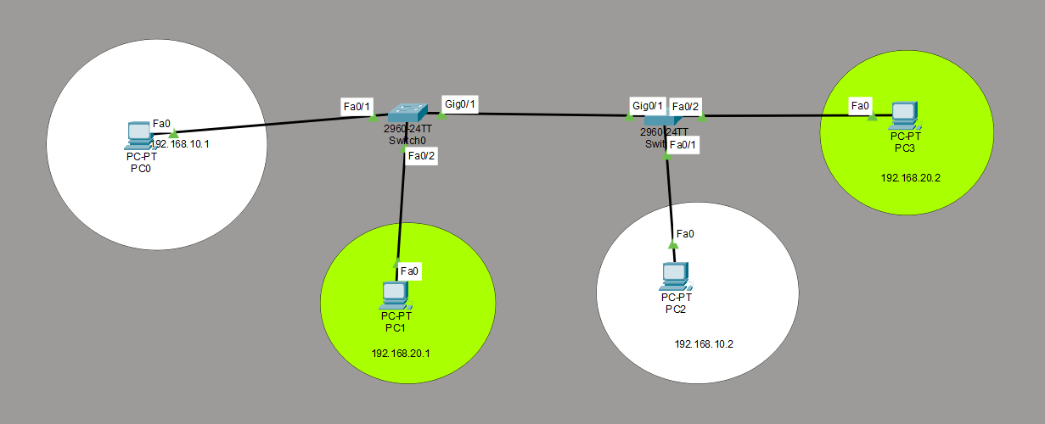
THE entire network

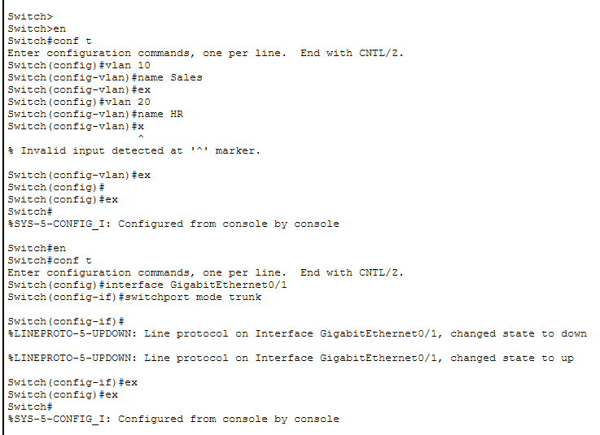
In both the switches in the network the gigabit ethernet ports have been switched to trunk ports

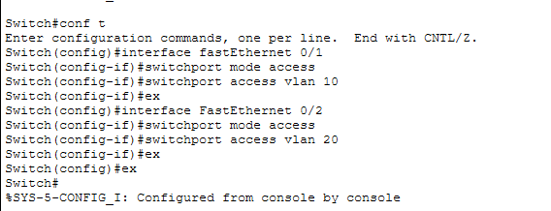
PCO and PC2 are in vlan10 and Pc1 and PC3 are in vlan20, have been configured
VLAN 10: PC0 (192.168.10.1) and PC2 (192.168.10.2) are in the white circles.
VLAN 20: PC1 (192.168.20.1) and PC3 (192.168.20.2) are in the green circles.

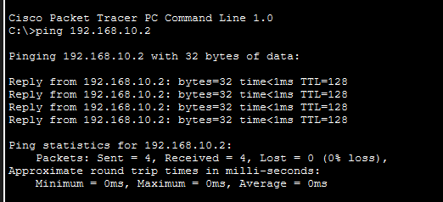
Ping between PC0 and PC2 will work since they are in the same VLAN i.e vlan10

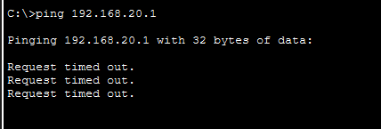
PING between PCO and PC1 will not work even though they are connected to the same switch because they are in different VLAN’s.

6. Change the native VLAN on a trunk port-Test for VLAN mismatches and
Troubleshoot.

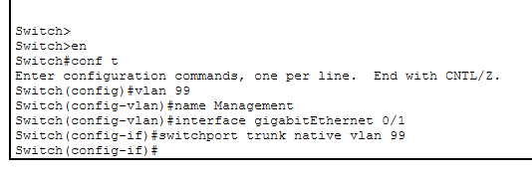
Once the trunk port has been changed to a non-native vlan error messages flooded both the switches CLI.
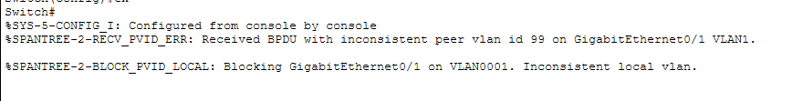

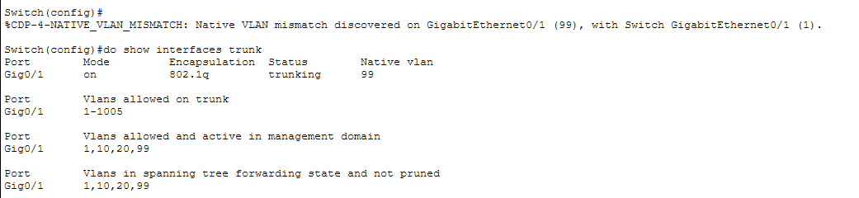
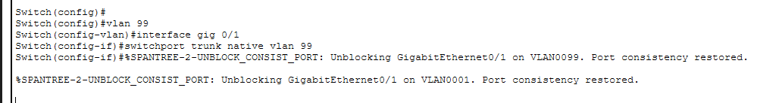
Once in port 2, it got changed we can see that port consistency restored message.

7. Configure a management VLAN and assign an IP address for remote access.Test
SSH or Telnet access to the switch.

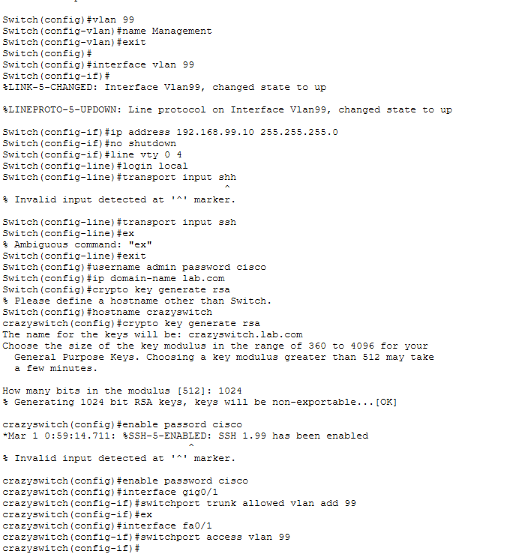

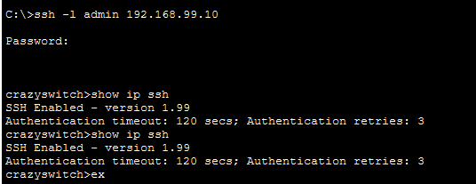

Step 1: Created the Management VLAN
I created VLAN 99 and named it "Management." This isolates administrative traffic from regular user traffic for better security.
Step 2: Configured the Virtual Interface (SVI)
I assigned the IP address 192.168.99.10 to the Switch’s Virtual Interface (Interface Vlan 99). This gives the switch an identity on the network so it can be reached by other devices.
Step 3: Prepared the Switch for SSH
I performed the three mandatory security requirements for SSH:
- Set a Hostname: Changed the name from the default to crazyswitch.
- Defined a Domain Name: Set it to lab.com.
- Generated Encryption Keys: Created 1024-bit RSA keys to encrypt the communication between the PC and the switch.
Step 4: Configured Local Authentication
I created a local user account (Username: admin, Password: cisco) and set an enable password. This ensures that only authorized users can log in and make changes to the configuration.
Step 5: Enabled SSH on Virtual Lines
I configured the VTY lines (0–4) to only allow SSH connections and told the switch to use the local user database for login credentials.
Step 6: Configured Network Ports
- Trunk Port: I updated the trunk link (Gig0/1) to allow VLAN 99 traffic to pass between switches.
- Access Port: I moved a PC's port (Fa0/1) into VLAN 99 so it could communicate directly with the management interface.
Step 7: Verified Remote Access
Using a PC's command prompt, I ran the command ssh -l admin 192.168.99.10. After entering the password, I successfully gained remote access to the switch CLI.

8. You have a Cisco switch and a VoIP phone that needs to be placed in a voice VLAN
(VLAN 20). The data for the PC should remain in a separateVLAN (VLAN 10).
Configure the switch port to support both voice and data traffic.

Sol:
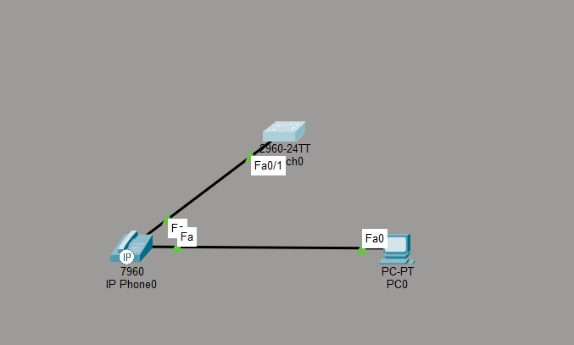
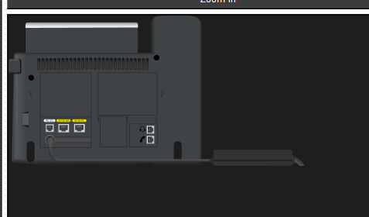
Connection is done to the ip phone power adapter.

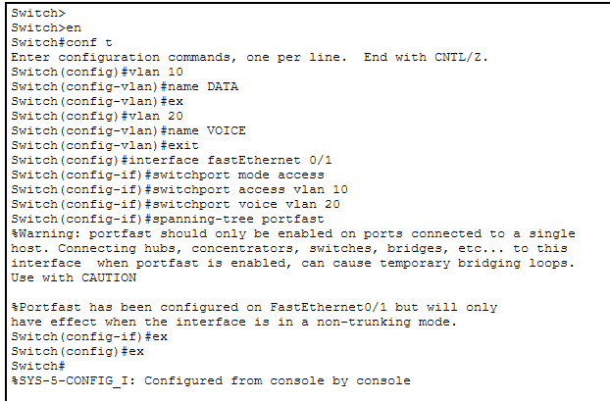
Configuration of voice vlan and data vlan has been done in the switch.

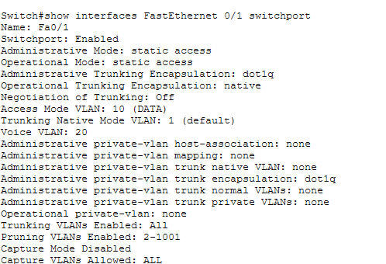
Here when the command ‘show interfaces Fastethernet 0/1 switchport’ is typed we can see that Access mode VLAN is 10 and Voice Vlan in 20.

9. You configured VLANs 10 and 20 on your switch and assigned ports to each VLAN.
However, devices in VLAN 10 cannot communicate with devices in VLAN 20.
Troubleshoot the issue.

Sol:

As we have already seen devices in VLAN 10 cannot communicate with devices in VLAN 20. This is because VLANS are separate broadcast domains. Devices in different VLANs cannot communicate at Layer 2. A Layer 3 devices such as router is required for communication between different VLANs and this process is called Inter-VLAN routing.

10. Try Inter VLAN routing with Router

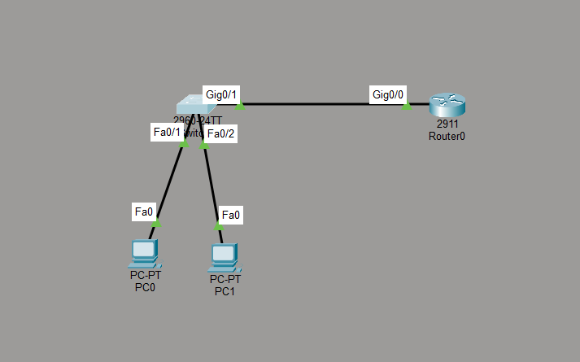
The network

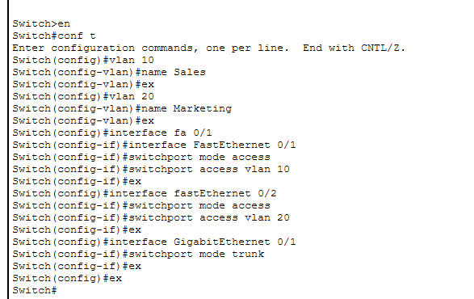
Switch Configuration

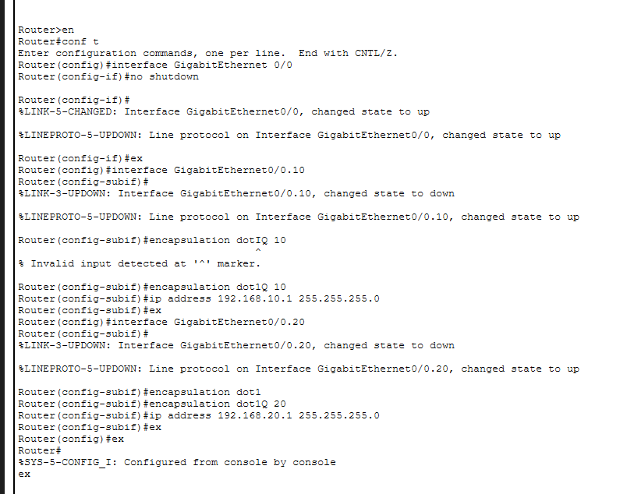
Router Configuration where sub ips were created and then connection was established .

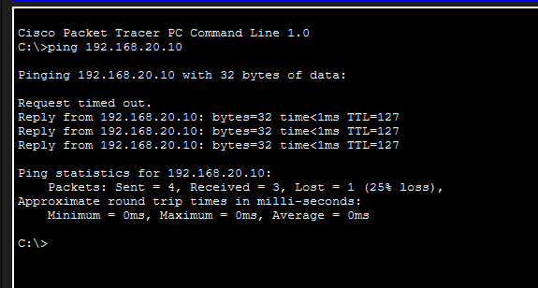
The ping between PC0 and PC1.

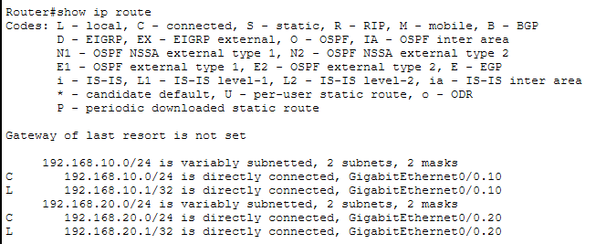

Technically, Inter-VLAN Routing (specifically the Router-on-a-Stick method) is the process of moving data between distinct Layer 2 broadcast domains using a Layer 3 device as the gateway.

11. Implement ACLs to restrict traffic based on source and destination ports.Test rules
by simulating legitimate and unauthorized traffic.
An Access Control List (ACL) is a sequential collection of permit or deny statements that apply to addresses or upper-layer protocols. In technical terms, it is a Layer 3 and Layer 4 filter used by network devices (like routers and firewalls) to control the flow of traffic.

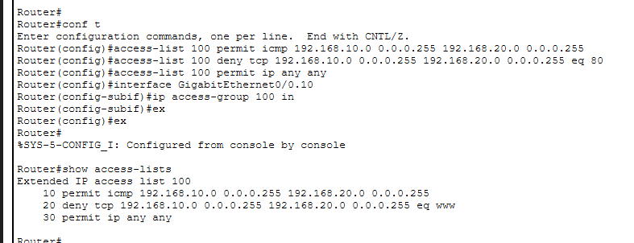

I implemented an Extended ACL (100) to enforce a granular security policy between VLANs. The configuration permits ICMP Echo Requests for diagnostic purposes while explicitly denying TCP-based web traffic (Port 80) to demonstrate unauthorized access control. The ACL was applied inbound on the sub-interface G0/0.10 to ensure efficient traffic filtering at the source.

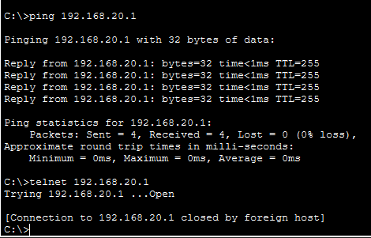

The real-time testing results (Figure X) verify that Layer 3 connectivity is established between VLANs, as evidenced by the successful ICMP echo requests to the 192.168.20.1 gateway. Furthermore, the Telnet test confirms that Port 23 is reachable ('Open'), though the immediate termination by the host indicates that the security protocols (ACLs) are actively managing unauthorized terminal access.
Traffic Type | Action | Technical Reason
Ping (ICMP) | Authorized | Matched the permit icmp statement.
Telnet (Port 23) | Blocked | Matched the deny tcp ... eq 23 statement.

12. Configure a standard Access Control List (ACL) on a router to permit traffic from a specific IP range.Test connectivity to verify the ACL is working as intended.
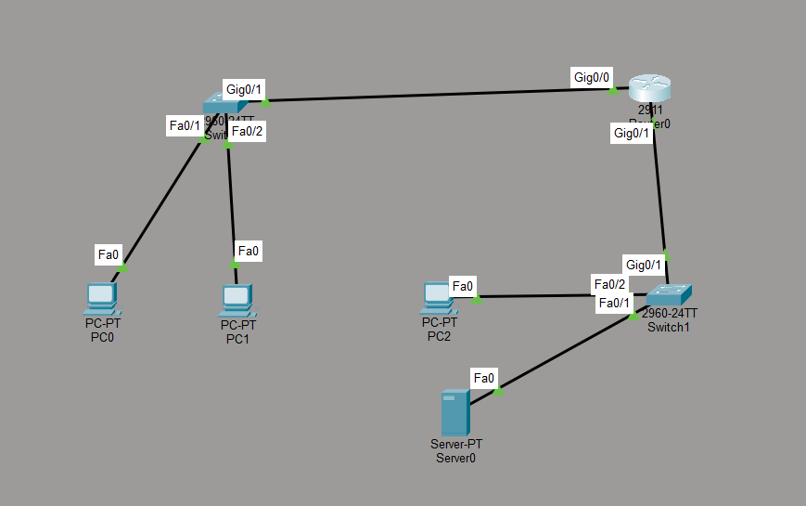
The network

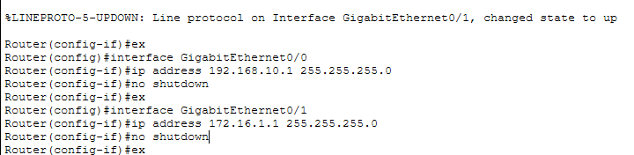
Gigabit Configuration in the router.

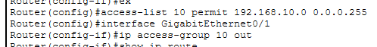
The ACL is configured for gigabit ethernet 0/1.

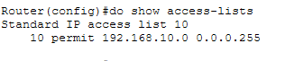
This above image clearly statesfor what the ACL is configured.
Traffic Source | Destination | Status | Technical Reason
192.168.10.0/24 | 172.16.1.0/24 | Authorized | Explicitly matched by access-list 10 permit.
172.16.1.0/24 | 192.168.10.0/24 | Blocked | Fails to match permit; hit by Implicit Deny.
Any External IP | 172.16.1.100 | Blocked | Fails to match permit; hit by Implicit Deny.

This is what is achieved from the ACL implemented.

13. Create an extended ACL to block specific applications, such as HTTP or FTP
traffic.Test the ACL rules by attempting to access blocked services.
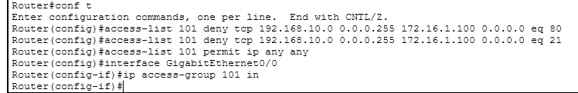
This is the configuration where the
Unauthorized Services: HTTP (Port 80) and FTP (Ports 21/20).
Authorized Services: ICMP (Ping) and all other IP traffic.

Test A: Testing Unauthorized HTTP Access
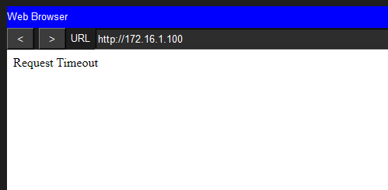
The server’s IP was typed in the PC0’s web browser and then ‘request timeout’ occurred.

Test B: Testing Unauthorized FTP Access
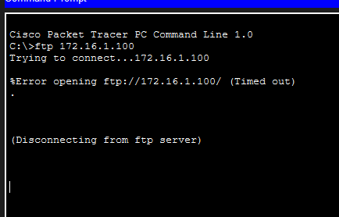
PC0 was not able to send ftp connection to PC1 since the ACL blocked it.
Test C: Testing Authorized Legitimate Traffic

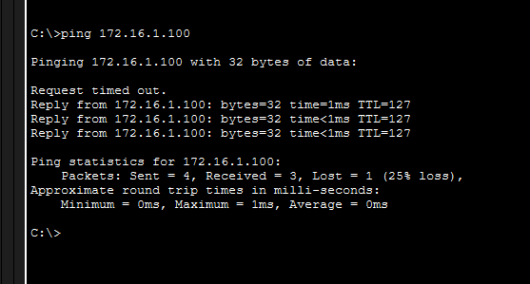
Whereas, PC0 ping connection to PC1 works.

14. Try Static NAT, Dynamic NAT and PAT to translate Ips
Sol:
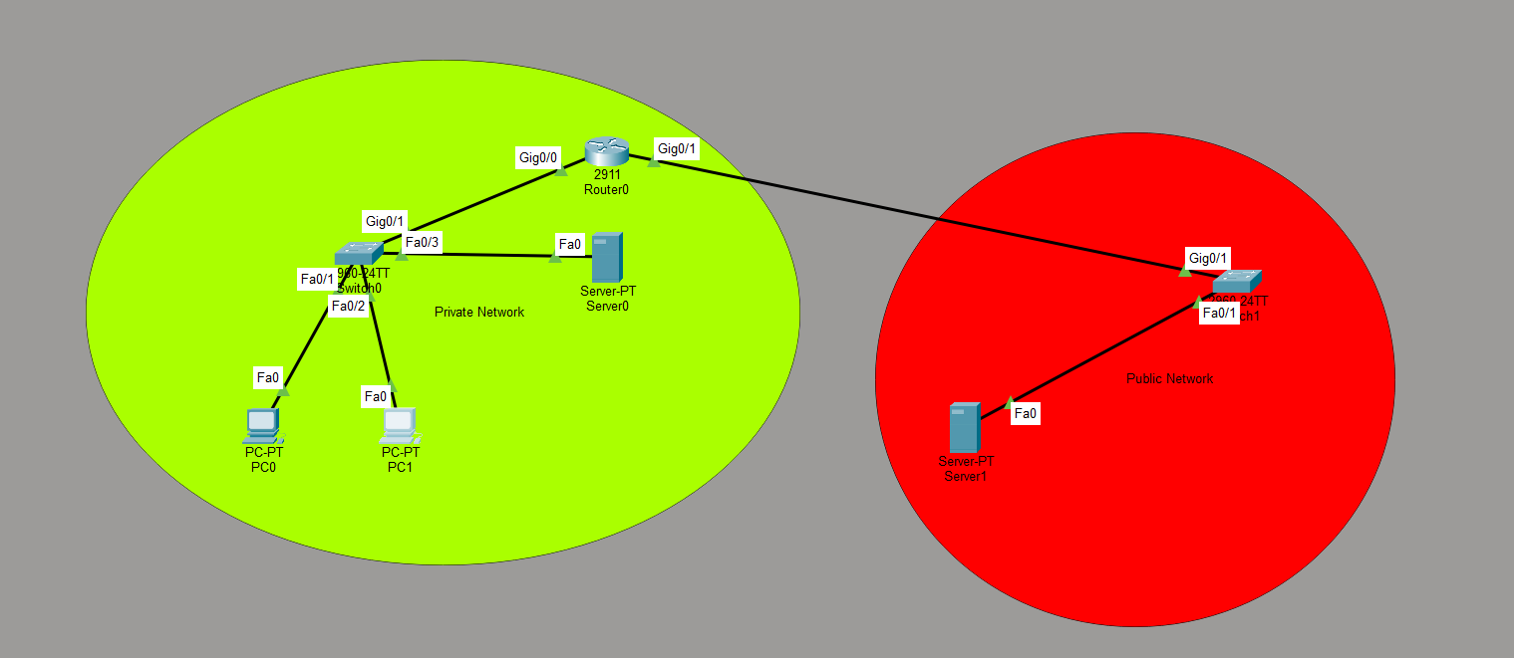
The network
Device | IP Address | Subnet Mask | Default Gateway | Device
PC0 | 192.168.10.10 | 255.255.255.0 | 192.168.10.1 | PC0
PC1 | 192.168.10.11 | 255.255.255.0 | 192.168.10.1 | PC1
Server-Int | 192.168.10.100 | 255.255.255.0 | 192.168.10.1 | Server-Int

STATIC NAT CONFIGURATION:
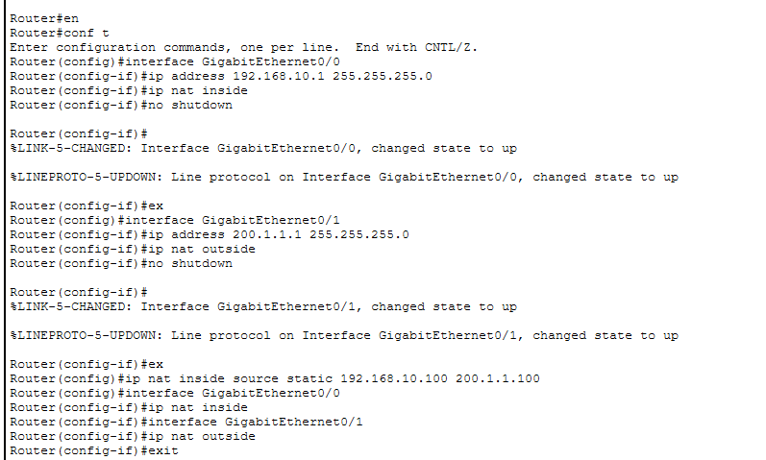
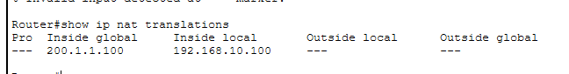
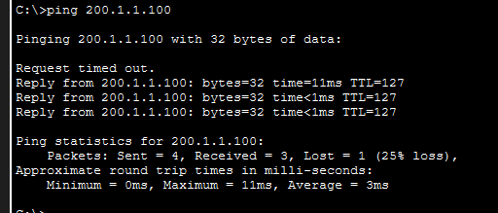

Static NAT is a Fixed 1-to-1 Mapping between a local (private) IP address and a global (public) IP address. Unlike Dynamic NAT, these mappings are manually configured in the Router’s NAT table and remain persistent regardless of traffic flow.

In this implementation, the following address categories were utilized:
- Inside Local IP (192.168.10.100): The RFC 1918 private address assigned to the internal host (Server) within the local area network.
- Inside Global IP (200.1.1.100): The public-facing IPv4 address registered on the NAT-Router’s Outside interface, representing the internal host to the external network.
The persistence of the entry confirms that the server is globally reachable, allowing external hosts to initiate connections to the internal resource—a critical requirement for web and application hosting in embedded systems architecture.

Dynamic NAT Configuration:
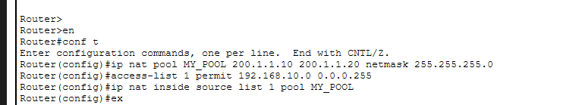

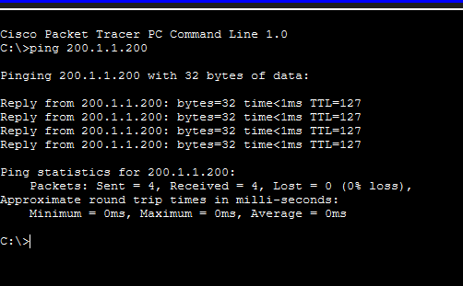
Ping from PCO and PC1 to the external server.

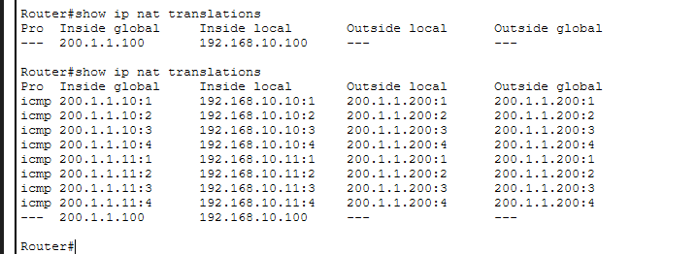

Dynamic NAT was configured to manage a limited pool of public IPv4 addresses ($200.1.1.10 - 200.1.1.20$) for the internal user segment ($192.168.10.0/24$). By utilizing a Standard Access Control List (ACL 1) to identify 'Inside Local' traffic, the NAT-Router dynamically allocates 'Inside Global' addresses on a demand-driven basis. This method provides enhanced security by masking internal host identities and prevents external-to-internal unsolicited traffic.

PAT Configuration:

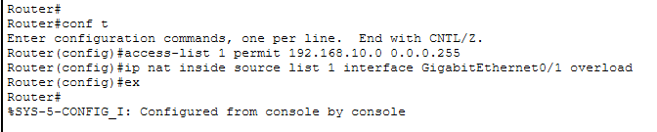

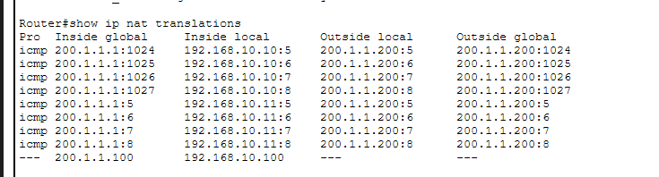
The captured show ip nat translations output justifies the successful implementation of Port Address Translation (PAT). By multiplexing unique Layer 4 identifiers (Sequence/Port IDs) onto a single 'Inside Global' IP address ($200.1.1.1$), the router demonstrates the ability to support multiple concurrent internal sessions ($192.168.10.10$ and $192.168.10.11$) using a single public-facing interface. Additionally, the persistence of the $192.168.10.100$ static entry confirms that the router maintains deterministic reachability for high-priority resources while simultaneously providing dynamic, overloaded translation for general client traffic

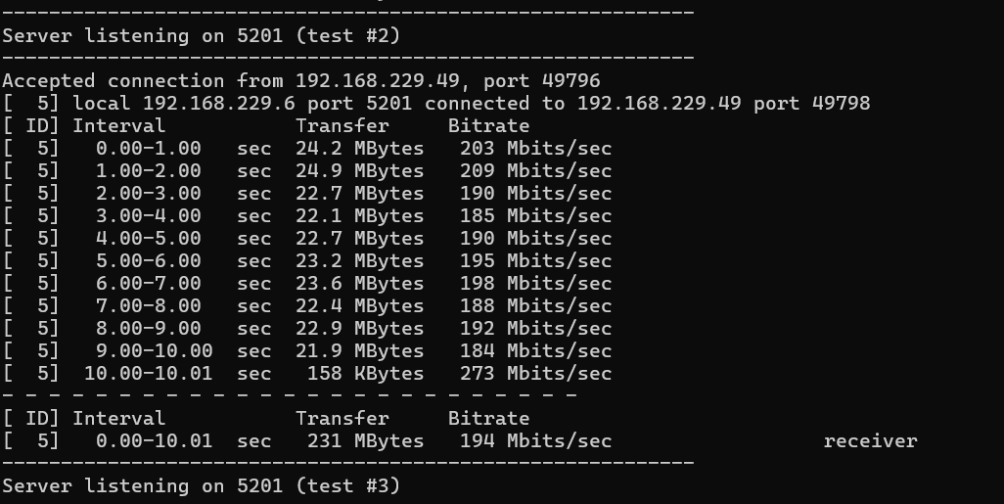

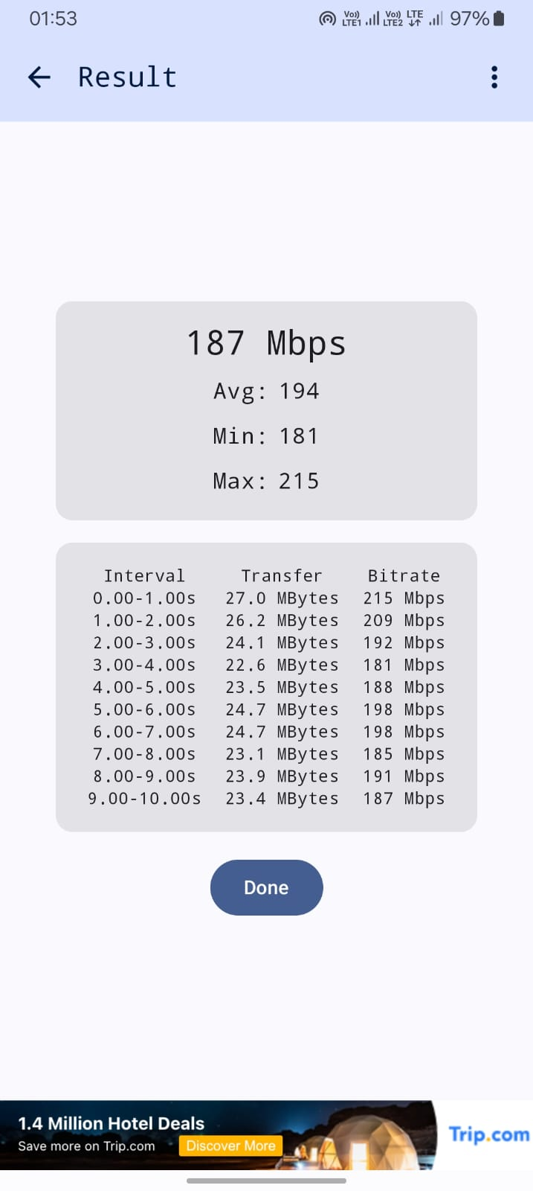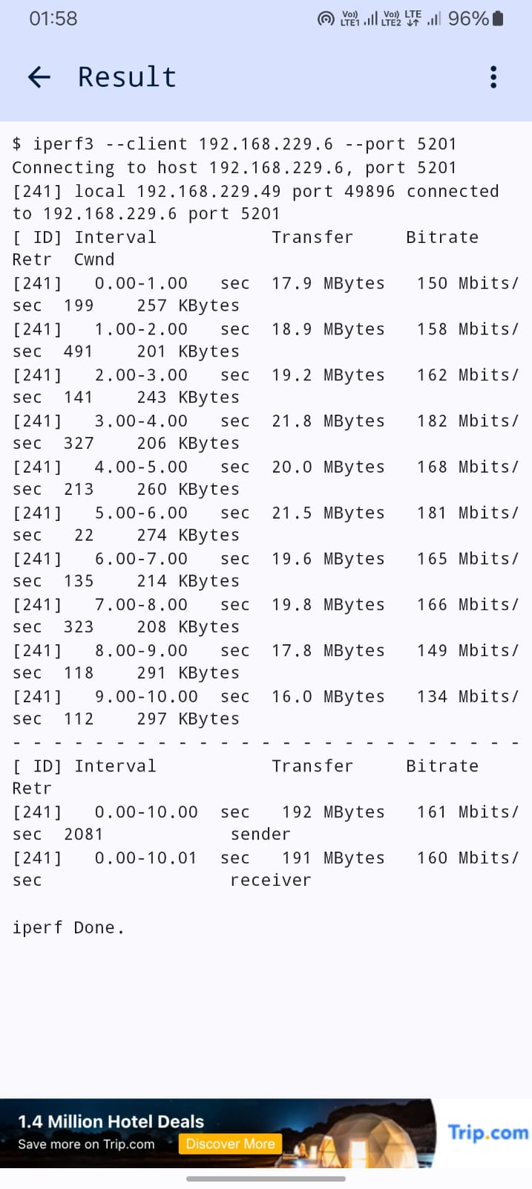
The iPerf3 analysis revealed a mean TCP throughput of 161 Mbps. While the bitrate is sufficient for high-definition streaming, the 2081 retransmissions indicate significant Layer 2/3 interference within the test environment. This highlights the 'Reliability vs. Speed' trade-off in TCP; the protocol successfully delivered 192 MBytes of data, but the high retransmission count suggests that a UDP test would likely result in noticeable packet loss.

